**Bangalore Institute of Technology**

**K.R. ROAD, BENGALURU-560004.**

**Department of Computer Science and Engineering**

**DBMS Mini Project Synopsis**

**College Event Management System**

|  |  |  |  |  |
| --- | --- | --- | --- | --- |
| **USN** | **NAME** | **BATCH** | **PHONE NO** | **E-MAIL** |
| 1BI19CS172 | Manohar Raj | C3 | 7483090054 | [manoharraj368@gmail.com](mailto:manoharraj368@gmail.com) |
| 1BI19CS182 | Vedant Badiger | C4 | 9008410945 | vedantbadiger4132@gmail.com |

Problem Domain: Education

Lab In-Charges:

20-12-2021

**2021-2022**

**For office use only:**

**Accepted :**

**To be modified :**

**Rejected :**

**Signature of the Lab In-Charges**

# Index

|  |  |  |
| --- | --- | --- |
| **SL NO.** | **CONTENT** | **PAGE NO.** |
| 01 | Title | 03 |
| 02 | Introduction | 03 |
| 03 | Problem Statement | 04 |
| 04 | Front-end and Back-end details | 04 |
| 05 | ER Diagram | 05 |
| 06 | ER to Relational Mapping | 06 |
| 07 | Modules | 07 |
| 08 | Applications | 07 |

# Title

Event Management System

# Introduction

A Student Result Management System is a system used to manage student result , exam data , subject data , student data and classes data.

The main purpose of this system is to reduce the manual errors and convert result system into computerised system.

Drawbacks of the conventional result management system:-

In conventional result management system, teachers spend a lot of time in writing down the marks scored by a student in a book. This Conventional approach includes maintainance of large records of students, which includes manual procedures like pen-paper work which leads to problems like:-

* Slow Processing
* Student has to approach the department to view his/her marks scored in a subject
* Manual changes in marks is not good looking and highlights correction errors

# Problem Statement

To Develop a system that will manage

* Information about various users
* Information about subjects offered in various semesters
* Marks obtained by students in internals and final exam
* Generation of reports

# Front-end and Back-end tool details

Front-end components:-

* Hyper Text Markup Language [HTML] 5
* Cascading Style Sheets [CSS] 3
* Bootstrap 5

Back-end components:-

* Java[Jakarta Service Packages(JSP)[formerly Java Server Pages]]
* MySQL

# Entity Relationship [ER] Diagram

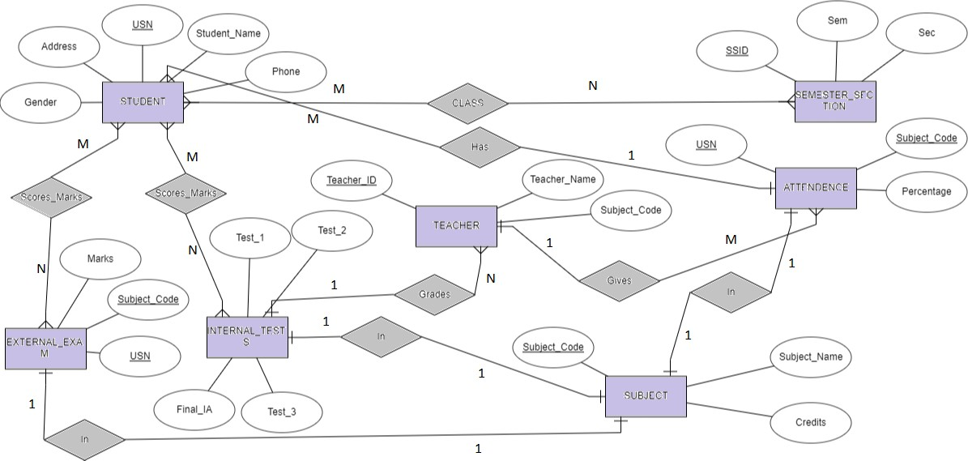

# ER To Relational Mapping

Category Table

|  |  |
| --- | --- |
| Category__id | Category |

Department Table

|  |  |  |  |
| --- | --- | --- | --- |
| Dept_no | Dept_Name | HOD | Contact |

Club Table

|  |  |  |  |
| --- | --- | --- | --- |
| Club_no | Club_Name | President | Contact |

|  |  |  |  |  |  |  |
| --- | --- | --- | --- | --- | --- | --- |
| Event_id | Event_name | Date | Time | Duration | Location | Amount |

Event Table

|  |  |  |  |  |  |  |  |
| --- | --- | --- | --- | --- | --- | --- | --- |
| Event_id | Name | USN | Sem | Branch | Phone | E-mail | Payment_stat |

Participants Table

Department event

|  |  |  |
| --- | --- | --- |
| Event _id | Category_id | Dept_no |

Club event

|  |  |  |
| --- | --- | --- |
| Event_id | Category_id | Club_no |

Company Event

|  |  |
| --- | --- |
| Event_id | Company_name |

# Modules

1. Student module:

In this module we have to enter roll number to see user or student result. When we enter wrong roll number it will show popup message incorrect roll number. When we enter correct roll number then it moves to next page where we can see results of different subject scored in tests and final exam.

1. Admin/Teacher module:

In this module we can add new student and add new result. If we want to add an existing roll number or student details then we get error message. We can also see student details and student result.

# Applications

Overcomes the drawbacks of Conventional Result Management System such as no pen-paper work is need to be carried out. Processing will be faster.

* + Students can easily check/retrieve their marks scored in a subject
  + Teachers can easily add and update the marks of a student scored in a particular subject
  + The data can be stored for a longer time without worrying for the damage caused by natural things